## How to Setup RStudio

1. Download an installer for [RStudio desktop](https://www.rstudio.com/products/rstudio/download/) for free.
2. Open the installer and follow the steps to install RStudio

## How to Make a new R Markdown Document

File → New File → R Markdown

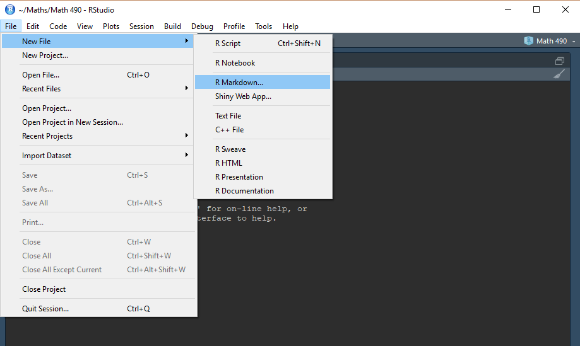

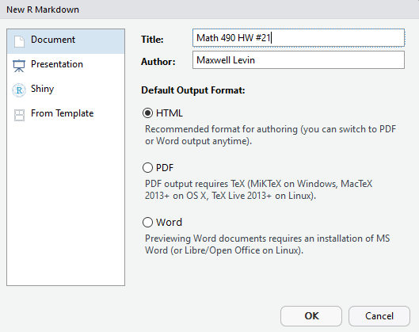

1. Title your document whatever you like and give it an author (you can change both of these whenever you like).
2. You can specify what type of output you would like. I prefer PDF, but it requires a version of LaTeX (download MiKTeX [here](https://miktex.org/download).) HTML is a great option if you don’t want to bother with LaTeX.
3. Once you select OK a new R Markdown document will be created. It should look something like this: 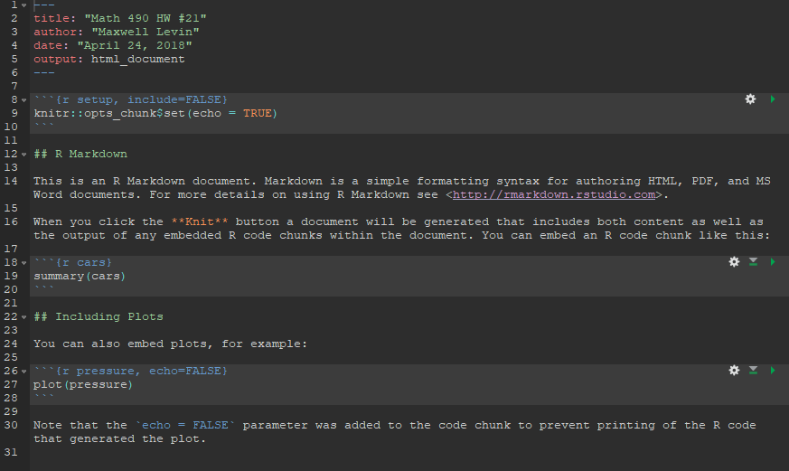
4. When you press the knit button it will create an html document that looks like this: